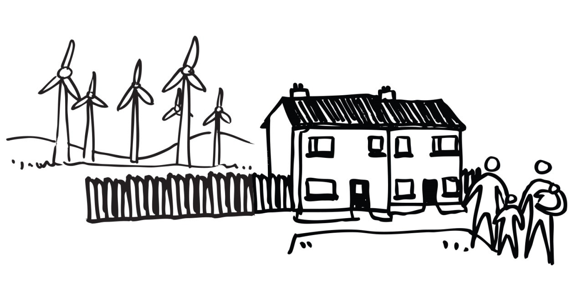

**From 10 August to 25 September**

**Have your say:**

**NEW CLIMATE EMERGENCY PLANNING POLICIES**

Cornwall Council is proposing new planning policies to help address the climate emergency. This will give us more power and will help us protect our environment by reducing carbon, and encouraging an eco-friendly approach to building, transport, land and energy production.

Visit: [www.cornwall.gov.uk/climatechangedpd](http://www.cornwall.gov.uk/climatechangedpd)

**Contact us**

Email**: climateemergencydpd**[**@cornwall.gov.uk**](mailto:xxxxx@cornwall.gov.uk)

Call: **0300 1234 151**

Or Write to us**: Climate Emergency DPD,**

**Cornwall Council – Planning, PO Box 676, Threemilestone, Truro TR1 9EQ**