Youth Engagement
The Youth Working Group met on Monday 26th February. We are currently looking for a PIC representative to attend the group, following the PIC AGM.
Main points:
- ASB Detached Outreach will be starting in May. The Working Group will meet at the end of May, for feedback and plan next steps.
- Action Plan has been updated, based on current cohort of children
- Numbers have dropped last few weeks but that is across all areas
- Young People answered the Former Toilet Survey
- Re-advertised sessions with Secondary Schools
- No issues or concerns
Community Junior Netball
Netball has just had a 3-week break, due to mock exams in the hall and half term. Two young people have left, and these spaces have been filled with young people from the waiting list. We currently have two young people on the waiting list.
The first Tuesday back, we had a lot of sickness. We had 19 young people attend. This session was supported by Peter Gribble, Lead Coach of the Lastonet Netball Club. To date, we have not had 30 young people attend every session, due to other commitments or sickness. If a young person misses two consecutive sessions, with no communication, they lose their space or if a young person misses too many sessions.
Photos taken: 20/02/24
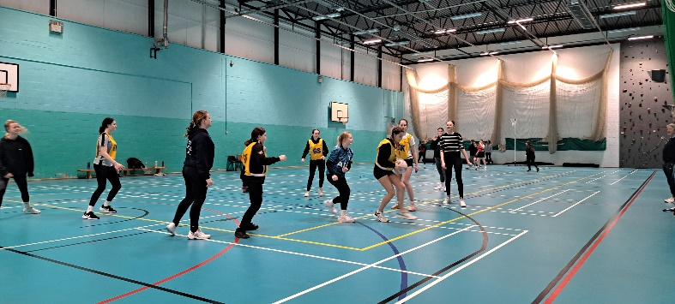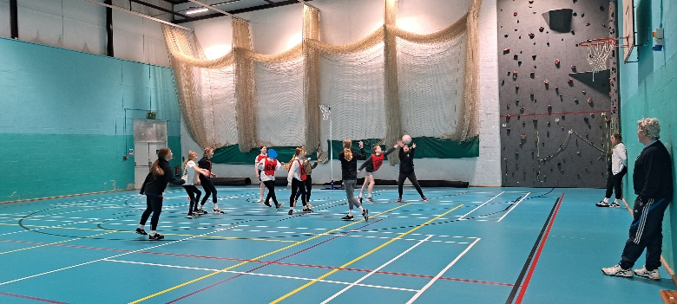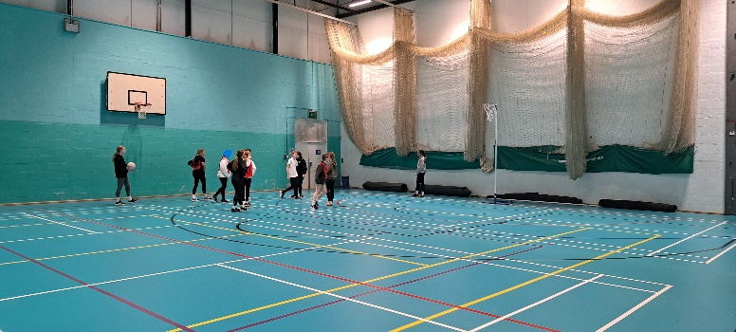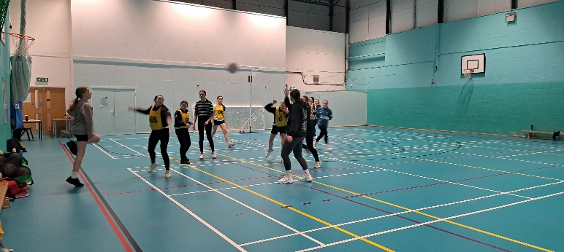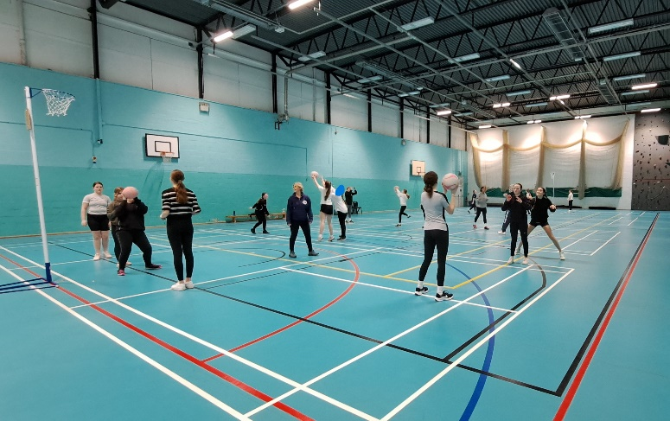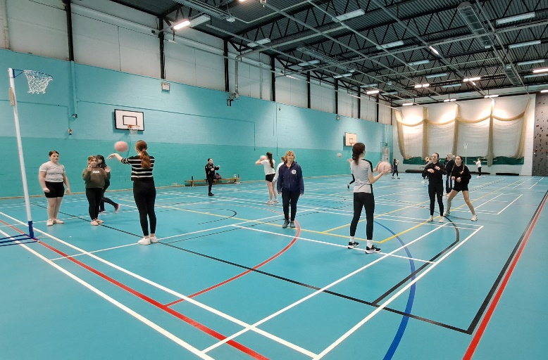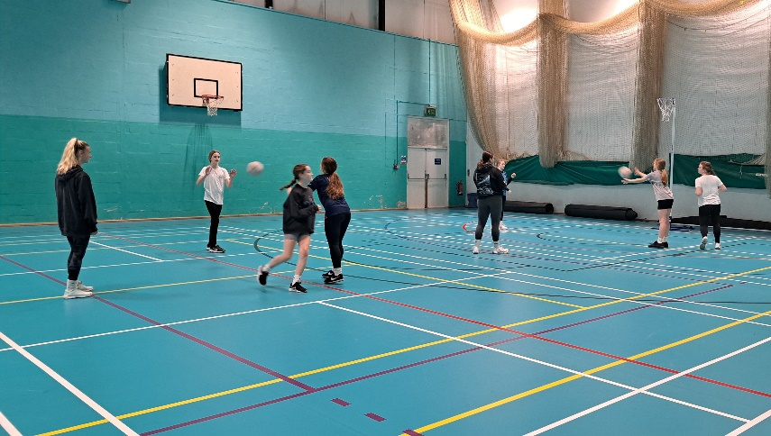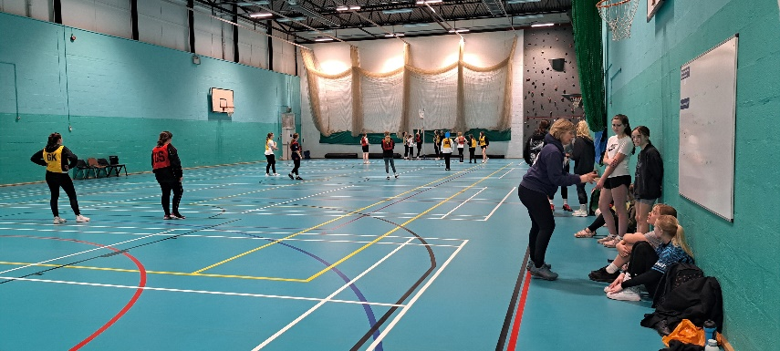
Exciting news – Active Cornwall would like to take this project forward from Easter 2024 to Easter 2025. The Volunteers are in the process of setting up a Sub-Committee, which will sit within the Lastonet Netball Club, who have been strong supporters of the these Community Junior Netball sessions. I hope to have a more concrete update in April for the Parish Council.

Dog Fouling
There have been reports on Social Media about the increase in Dog Fouling. This is following the same pattern that the parish council noticed last year, which prompted us to work with the school and Gwel an Mor.
Due to current parish council capacity, this project hasn’t any updates. If you are interested in volunteering and assisting with this project, please contact Vicki Webb – vickiwebb.ppc@gmail.com

Warm Welcome Portreath – Community Catch Ups
We have a rota until June 2024. The catch ups vary in attendance, but we have seen a decline.
Our most recent guest speakers came from the community hub project ‘Imagine IF’. They gave an interesting talk, and they can offer parishioners of Portreath, a lot of support within a hub, which is centred around Health and Wellbeing. Portreath Parish Council are in talks with this organisation, to see how a ‘hub’ might work in the village. We are looking at asking for feedback from residents in April/May, once the Lighthouse Hill project consultation has been completed.
If you are interested in this, please contact Cllr Vicki Webb or Cllr Gill Tull gillianportreathpc@gmail.com
Guest Speakers:
21st March – We welcome Grace, from The Ladder, in Redruth
April – No guest Speaker – Egg Extravaganza!
16th May – We welcome, RAF Portreath

April Break – 4th April – 11th April

Police Liasion Group (PLG) - Next meeting booked: Tuesday 30th April @ 10am

