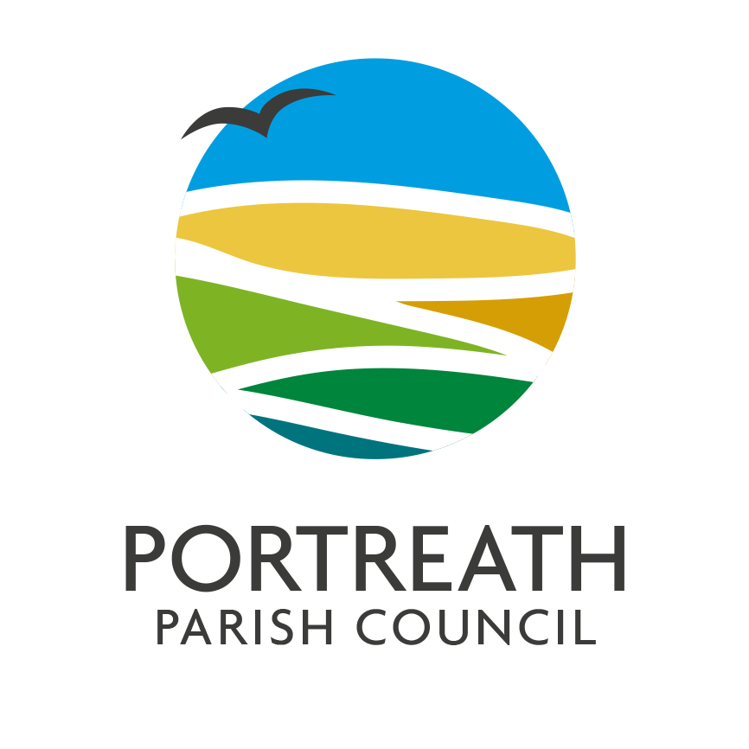
GRANTS POLICY

Adopted 4th May 2021

Review Due: on or before May 2022

- INTRODUCTION
Portreath Parish Council is committed through this policy to promote Portreath Parish as a vibrant, active and sustainable community and to contribute to the development of various projects and services that benefit the community. In so doing, the Council is aware of its responsibility for public funds and for the distribution of these funds to be managed in accordance with proper standards. A grant payment is made by the Council for the specific purpose it is claimed for.

- TYPE OF GRANTS AVAILABLE
There are three types of grant available:
- Small grants for grants up to £ £300
for voluntary / community group, registered charity, not for profit organisation or Community interest Company (CIC). Open for application at any stages in the financial year.

- Large Grants for grants over £300
for voluntary / community group, registered charity, not for profit organisation or Community interest Company (CIC). Must be applied for by October for inclusion in the following year’s budget.

- Emergency Grants for grants over £300
for voluntary / community group, registered charity, not for profit organisation or Community interest Company (CIC). Open for application at any stage of the financial year.

- ELIGIBILITY FOR GRANTS
To be eligible for a grant from Portreath Parish Council, the applicant must be able to meet all of the following criteria:
- Be a voluntary / community group, registered charity, not for profit organisation of Community interest Company (CIC) that can tangibly benefit for the benefit of the people of Portreath.

- Provide a completed grant application form signed by the person authorised to apply for the grant on behalf of the organisation. Application forms are available from the parish Clerk or from the website.
- Be able to demonstrate sound financial management. Ideally last year’s accounts should be provided.

- Where other funding is required, the grant is conditional on the other funding also being available.
- CRITERIA FOR SELECTION
- Sustainability – Are the aims and objectives of the project clear? Projects must demonstrate sustainability and long-term value for money.

- Management – Has the organisation obtained the correct permissions, have they nominated a responsible person to ensure that the project will be implemented, are they acting within current legislation? Only projects that are properly managed and compliant will be funded
- Need - There should be clear evidence of the need.

- Self-help measures - Where self-help measures have been put in place, applications are more attractive. Have you applied for other grants?

- Beneficiaries - The grant must be for the benefit of the people of the Parish of Portreath.

- APPLYING FOR A GRANT
- Applications for small grants will be considered at full council meetings which are usually held on the first Monday of the month, until the funding has expired for the financial year.

- Applications for large grants will be considered at the October meeting for inclusion of the council budget for the following financial year.

- Applications for emergency grants will be considered at full council meetings which are usually held on the first Monday of the month, until the funding has expired for the financial year.

Grant application forms should be completed as fully as possible and return to the Parish Clerk.
Incomplete or incorrect forms will be returned so that full information can be provided to the council prior to discussion.

If you need assistance with completing the application form please contact the Parish Clerk.

- IF YOU ARE SUCCESSFUL
If you are successful you will be notified by the Council in writing and payment will be made into your organisations bank account by BACS. Please ensure that the bank account details provided are correct.

Financial support from the Council should be acknowledged in any publicity relating to the project and in the organisation’s annual report. Copies of this material should be sent to the Council. Where possible, items purchased with Council’s support should be marked as such.

The funding may only be used for the purposes set out in the grant application.

If it transpires that funding cannot be utilised for the agreed purpose you must notify the Council at the earliest opportunity.

- ON COMPLETION OF THE PROJECT
Confirmation in writing is to be given by the “Project End Date” that the project has been completed. The letter should verify that the funding has been used for the agreed purpose. A brief statement showing how the grant was spent and how successful it was will be required.

If for any reason the entire grant monies are not fully used then the surplus must be returned.

For large grants you may be asked to provide a presentation for the Annual Parish Meeting on the use of the grant.

portreathparishcouncil@gmail.com
Chairman – Councillor Mr Ian Stewart
Clerk to The Council - Lucy Jose
16 Glenfeadon Terrace, Portreath, Cornwall TR16 4JX – 01209 842370
www.portreathpc.co.uk
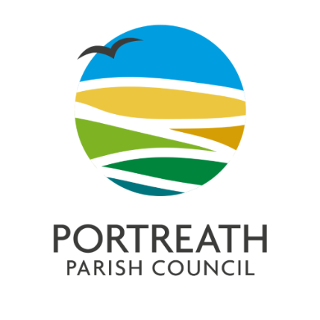

GRANT APPLICATION FORM

Portreath Parish Council invites grant applications, which primarily support local organisations and which directly benefit residents of the Parish.

1. NAME OF ORGANISATION:

2.CONTACT DETAILS:
Contact Name
Email Address
Telephone Number
Website
Address

3. VAT REGISTERED: YES / NO

4. REGISTERED CHARITY: YES / NO  Charity Registration No: ……………………….. |  | 5. DATE ORGANISATION ESTABLISHED:

6. DESCRIPTION OF ORGANISATION INCLUDING AIMS

7. MEMBERSHIP
Total Membership / Service Users:
Membership / Service Users resident in Portreath Parish

8. REASON FOR GRANT REQUEST: (e.g., details of project together with numbers of those involved in the project, members and/or others, equipment, event, how many Portreath residents will benefit from this application?)

9. PROJECT END DATE:

10. AMOUNT OF GRANT REQUESTED
(See Portreath Parish Council Grants Policy. If you are registered for VAT, it should not be included in the amount requested)
11. WHO HAVE YOU APPLIED TO FOR OTHER GRANTS: (e.g., organisations applied to and amount requested / amount received)

12. FINANCIAL INFORMATION: (Please attach last year’s accounts.
If application granted, please provide bank account details. All grants will be paid by BACS transfer (please include a copy of a recent bank statement with this application)
Account Name
Sort Code
Account Number
Signature of Signatory 1
Signature of Signatory 2

13. Checklist of Supporting Documentation / Information

Confirmation of any matched funding support (Large Grant Application Only)
Your organisation’s governing document (e.g. Constitution, Memorandum and Articles of Association, Trust Deed etc.)
Last year’s accounts
A copy of a recent bank statement (for the account grants should be paid to if successful.)
Risk Assessments if required
Cost estimates or price quotations
Other supporting information (optional)

14. DECLARATION
I hereby certify that to the best of my knowledge all the information contained within this application is correct and I confirm that I understand, agree and accept the terms and conditions of the grant as set out in the Grant Policy for the allocation of grants and that I am authorised to apply for a grant from Portreath Parish Council on behalf of my organisation.

Name
Signature
Date

(person authorised to apply for and on behalf of the organisation named in Item 1)

Please return your completed form to the Clerk, 16 Glenfeadon Terrace, Portreath, TR16 4JX or submit by email to: Portreathparishcouncil@Gmail.com

Notes:
The Parish Council considers grant applications from local organisations each year and successful applications do not imply an automatic future success – each is considered on its merits and against availability of funds. Please see Portreath Parish Council Grants Policy. Depending on circumstances, organisations that are successful in their grant application may be invited to attend a presentation ceremony for publicity purposes.

Office Use Only:
Date Application Received
Small/Large/Emergency Grant
Supporting Documentation Checked
Date Brought to Full Council
Grant Approved?
Date Applicant Contacted with Outcome
Date Grant Paid
Date End of Project Report Received
Invited to Annual Parish Meeting?

